1. Cài đặt Window server 2016 + AD

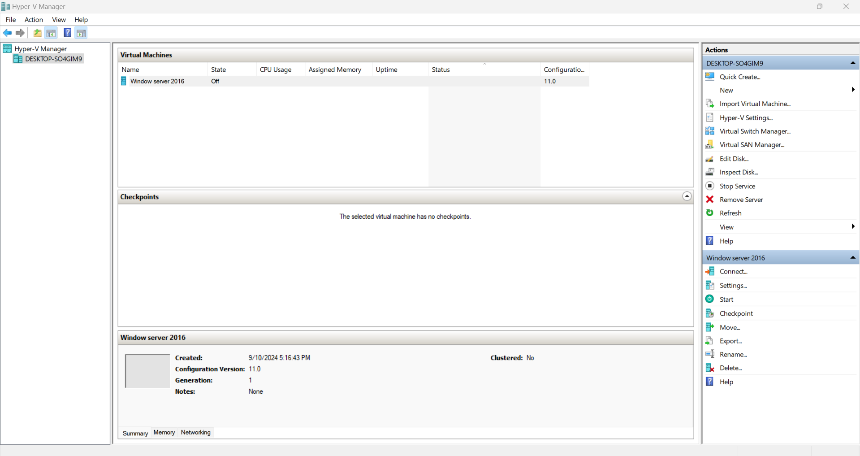

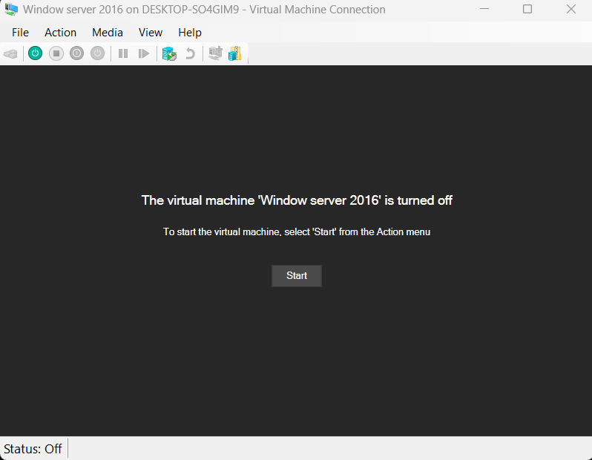

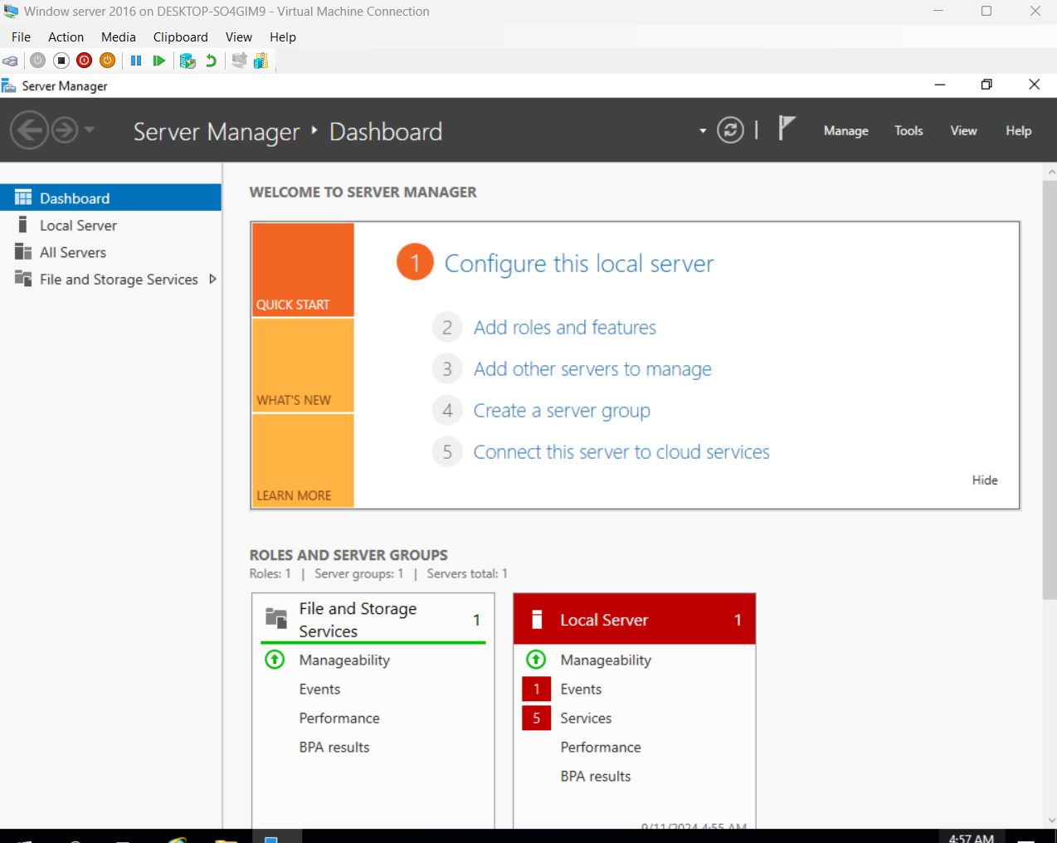

1. Tìm kiếm các lỗ hổng sử dụng CSDL online và off-line (searchsploit)

Searchsploit -h

searchsploit afd window local

searchsploit -t oracle windows

searchsploit linux kernel 3.2 --exclude="(PoC)|/dos/"

Searchsploit windows server 2016



